SARGENT-WELCH
V W R L I € N T I /='..! C
911 Commerce Court • Buffalo Grove * Illinois 60089-2375
1-800-727-4368 ! •
MATERIAL SAFETY DATA SHEET
11
lEAD CAREFULLY BEFORE USING CHEMICAL j
1SHA requires that this form be kept on file. i
roduct No. C3763R • j_
roduct name IRON III CHLORIDE,
6-HYDRATE |
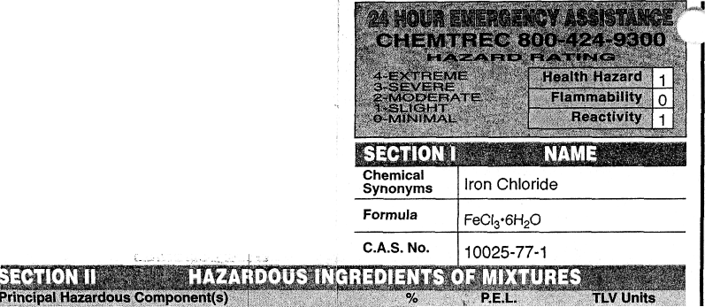
I/A  * chemical subject to the reporting requirements of SAI |  |  | W Title III.
SECTION III PHYSICAL DATA
Melting Point (T) |  | 37°C \ | Specific Gravity (H₂0=1) ₁ ^
Boiling Point (T) |  | 280-300°C (loses water/dec.) by volume (%j^{e} f\|/A
Vapor Pressure (mm Hg) |  | N/A | Evaporation Rate  < =D N/A
Vapor Density (Air=1) |  | N/A
Solubility in Water |  | Very:
Appearance & Odor |  | Yellow/brown | crystals/lumps, slight hydrochloric odor.
Flash Point (Method Used) | llillllliM^ |  | crystals/lumps, slight hydrochloric odor.
Flash Point (Method Used) | N/A |  | Flammable Limits in Air Lower Upper
Flash Point (Method Used) |  |  | % by Volume
Extinguisher Media | i Use any mediunji suitable for extinguishing supporting fire.  [
Special Firefighting Procedures
In the event of a fire, wear full protective clothing and NIOSH approved
self-contained breathing apparatus with full facepiece operated in the pressure
demand or other positive pressure mode. ;
Unusual Fire and Explosion Hazards '•
Not considered to be a fire/exp|losion hazard.

SECTION V
:•"'""..-. •
1 mg/m³ (as Fe) TWA
Effects of Oyerexp
Acute: Irritation and possibly burns to skin, eyes, lungs, mucous membranes, and Gl tract. Nausea. Chronic: Systemic metal poisoning hazard. Liver/kidney damage.
Emergency and First
Skin: Remove any contaminated clothing. Wash skin with soap or mild detergent and water for at least 15 minutes. Get medical attention, if irritation develops or persists. Eyes: Wash eyes with plenty of water for at least 15 minutes, lifting lower and upper eyelids occasionally. Get medical attention immediately. Inhalation: Remove to fresh air. If not breathing, give artificial respiration. If breathing is difficult, give oxygen. Call a physician. Ingestlon: If swallowed, induce vomiting immediately by giving two glasses of water and sticking finger down throat. Never give anything by mouth to an unconscious person. Call a physician immediately.
REACTIVITY DATA
Stability Stable 8 Unstable Q
Incompatibility (Materials to Avoid)
Hazardous !
Decomposition Products
Conditions to Avoid
None
HEALTH HAZARD DATA
' ,J?
Conditions to Avoid
None
Metals, allyl chloride, water (in water may produce hydrochloric acid fumes).
Hydrogen chloride fumes.
Hazardous Polymerization
Will Not
5J^{ay} Q Occur '-'
Released or Spilled
Steps to be Tak
Remove all sources of ignition. Ventilate area of leak or spill. Clean-up personnel may require protection from inhalation of dust. Spills: Clean up in a manner that does not disperse dust into air.
Waste Disposal Method
Discharge, treatment, or disposal may be subject to Federal, State or Local laws. These disposal guidelines are intended for the disposal of catalog-size quantities only.
Dispose in a RCRA approved waste facility or sewer the neutralized slurry with excess water if local ordinances allow.

Respiration: Protection (Specify Type) | Dust
Ventilation | Local Exhaust , | X Speci«
Ventilation | Mechanical (General) | X Other
Protective Gloves  • . • . •[• • •••'•••. | Rubber | Eye Protection | Goggles
Other Protective ,  Equipment : ;i | Lab Coat
SECTION IX SPECIAL PRECAUTIONS
iiisliil • ! '•'•••^'^•••••^••••••••••-^•li
Keep container tightly closed when not in use.
Store in a cool dry location.

Other Precautions
Read label on container before using. Do not wear contact lenses when working with chemicals.
None

D.O.T. Corrosive solid, acidic, inorganic, n.o.s. (Ferric chloride, 6-hydrate), 8, UN3260, PGIII
Approved by Steven C. Quandt Effective Date 04/16/96
For laboratory use only. Not for drug, food or household use. Keep out of reach of children.
tent to other information gathered by (hem and must

