">
material safety data sheet
1EAD CAREFULLY BEFORE USING CHEMICAL )SHA requires that this form be kept on file.
toduct No. _C4483I
PCTASSIUM. NITRATE
roduct
Principal Hazardous
Potassium Nitrate*
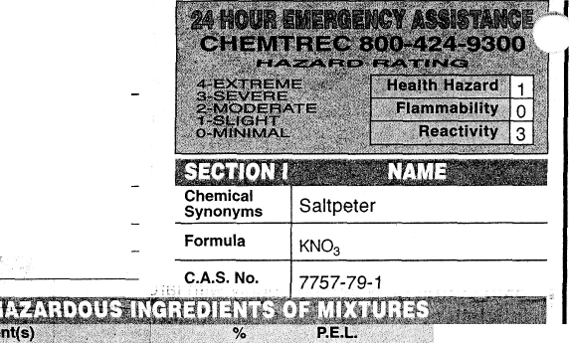
SARGfiNT-WGLCH
e n t i f i c
alp Grove * Illinois 60089-2375
V W R
911 Commerce Court • Buf
1-800 727-4368
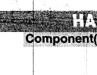
100
None
TLV Units
Established

HEALTH HAZARD DATA
SECTION V
Threshold Limit Value
None Established.
Effects of Overexposure
Mildly irritating to eyes, skin and mucous membranes. Prolonged inhalation of dust may cause irritation. LD50 orally in rabbits: 1.166g anion/kg.
Emergency and First Aid Procedures
Eye contact: Irrigate with running water for 15 minutes. Consult physician. Skin contact: Wash thoroughly with large amounts of water. Inhalation: Remove to fresh air, consult a physician.

Stability

Stable
Unstable Q
Mixtures with reducing agents may detonate by heat or shock.

Incompatibility (Materials to Avoid)
Hazardous Decomposition Products
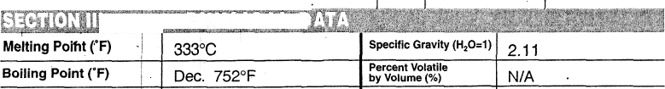
* chemica^subject to the reporting requirementsjrfjjARATitle III

.,-, i i> i * " «tiLnii-"fci*
ml Jt I 1&
Evaporation Rate ....
( =1) N/A
Vapor Pressure (mm Hg)
N/A
N/A
Vapor Density (Air=1)
31.6g/100ml@20°C
Solubility in Water
White crystal or powder; odorless.
Appearance & Odor
TWWW
Reducing agents, combustible material, flame heat.
When involved in fire, yields toxic, gaseous oxides of nitrogen.
Hazardous Polymerization
Conditions to Avoid
N/A

May Occur
^PROCEDURES
Steps to be Taken in Case Material is Released or Spillevtjjig; •,,_
Recover dry if possible. Immediately remove and dispose of any spilled nitrate.

Flash Point (Method Used)
Non-flammable
Flammable Limits in Air % by Volume
N/A
Upper
N/A
Waste Disposal Method
Discharge, treatment, or disposal may be subject to Federal, State or Local laws. These disposal guidelines are intended tor the disposal of catalog-size quantities only.
Small quantities may be flushed to sewer with large amounts of water.

Extinguisher Media
Welter

Special Firefighting Procedures ;
Wear self-contained breathing apparatus. Flood with large quantities of water; when large quantities are involved, material may melt or fuse; application of water may scatter molten material.
/^{R}SH«!iihr^{tl}Tl^{l}DSr^{>tectlon}- NIOSH approved nuisance dust mask type
(specuy type)
Ventilation | Local Exhaust | Recommended | Special
Ventilation | Mechanical (General) |  | Other
Protective Gloves | General purpose wotk gloves Ey'_{e}' |  | 'rtitection C | Chemical safety glasses
Other Protective Eauioment | Full cover work clothes

Unusual Fire and Explosion Hazards

Spontaneous reaction may occur with easily oxidizable material; increases flammability of any combustible material.

SPECIAL PRECAUTIONS
Precautions to be Taken in Handling & Storing , ;
Keep container tightly closed when not in use.
No smoking, no open sparks or flame, no reducing agents in area. Area should be equipped with sprinkler system.
Other Precautions , "•'._• .••.• . : ~~~" • ;••-;• • . •. ; •.• ••
Read label on container before using. Do nol wear contact lenses when working with chemicals.
Wash thoroughly after handling.

D.O.T. Potassium nitrate, 5.1, UN1486, PGIII
Approved by Steven C. Quandt
Effective Date
09/13/95
For laboratory use only. Not for drug, food or household use. Keep out of reach of children.

