Maintenance Supply Company, Inc.
Post OFFICE BOX 498
HUNTERSvlLLE NORTH CAROLINA 23078
- MATERIAL SAFETY DATA SHEET - /
COMPLIES WITH USDL SAFETY AND HEALTH REGULATIONS (29 CFR 1910.12
Emergency Phone (704) 875-6513
MSDS REFERENCE 16940 Revision Date 4/14/89
SECTION1 - I DENT IF I CAT I ON

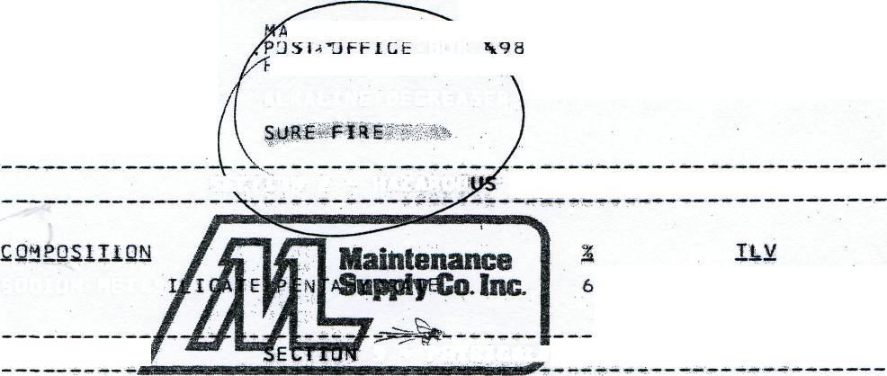
,INTE^AMCE SU><LY SERVICE CORPORATION
BOX lUNTERSV'lLLE, '.MORTH CA3,dLINA 28078
MANUFACTURER
PRODUCT: TRADE NAHE:
ALKALINE-0EGREASER
INGREDIENTS
SECTION 2 - HAZARDO

SOOIUM METAS
NOT ESTABLISHED L050 800 MG/KG ( R AT J
3 * THYSICALJOATA

BOILING POINT: 212 DEGREES F.
SOiUSItlTY ..... I-M- WATES2- 100-%- ...... •• ..... • ......... •• • ..... - ..... • •- ..... ..... •- .......... ......
SPECIFIC GRAVITYt «H20=1.5s 1.0
PERCENT VOL4TILE BY VOLUME: 38
P H : 12.7
APPEARANCE AND ODOR: TURQU3ISE LIQUID WITH LEMON ODOR
SECTION 4 -FIRE AND EXPLOSION HAZARDS
NOT FLAMMABLE
SECTION 5 – HEALTH HAZARD DATA
THRESHOLD LIMIT VALUE: NOT ESTABLISHED
PRIMARY ROUTES OF ENTRY: SKIN ABSORPTION; INGESTION
EFFECTS OF OVEREXPOSURE: EYES:SEVERE IRRITANT SKIN: SEVERE IRRITANT
INGESTION: SEVERE GASTROINTESTINAL DISTRESS
MEDICAL CONDITIONS AGGRAVATED BY QVEREXPOSURE: PRIOR SKIN, GASTROINTESTINAL DISORDERS
EMERGENCY FIRST AID PROCEDURES
EYES: FLUSH WITH WATER FOR 15 MINUTES; SEE A DOCTOR IMMEDIATELY.

SKIN: FLUSH WITH WATER FOR 15 MINUTES. IF IRRITATION
persists contact a physician,
ingestion: drink large qjamtities of milk or water,
D0 not induce vomiting, go immediately to emergency room of hospital*
chemicals in this product are not currently listed as
carcinogens.
section 6 -_reactivity data
stability: stable
hazardous polymerization: will mot occur
incompatibility: agios
section 7 - spill or leak procedures
FLUSH INTO DRAIN WITH LARGE QUANTITIES OF HATER*
SPILL OR LEAK PRECAUTIONS: SHALL SPILLS:
USE ABSORBENT MATERIAL TO SOAK UP MATERIAL. DISPOSE OF WASTE AT APPROVED LANDFILL IN ACCORDANCE HITH STATE REGULATIONS.
LARGE SPILLS:
FOLLOW STATE AND LOCAL REGULATIONS FOR DISPOSAL OF LARGE NDN-RECLAIMABkE SPILLS.
disposal;
SECTION 8 * SPECIAL PROTECTION

SECTion 9 – Precautions – handling, storage and usage
PROTECTIVE GLOves: Use when handling
EVE PROTECTion Use Safety Glasses or goggles
Other protective equipment: safety apron

Precautions to be taken in handling and storage: store away from acids.
Other precautions: if concentrate is spilled on clothes, wash thoroughly before reuse
SECTION 10 »- REGULATORY CONTROLS
department of transportation:
dot classification:'corrosive
dot proper shippin3 name: corrossive liquid Nos
OTHER DOT iNFORMATIOn: UN 1760

